Photoform Jake Decoy

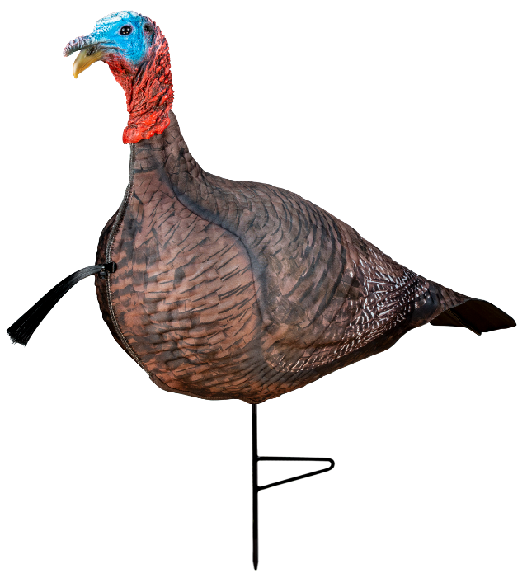
SKU | NAME | UPC | AVG RETAIL
69069 | Primos Photoform Jake Decoy | 0-10135-69069-4 | $79.99
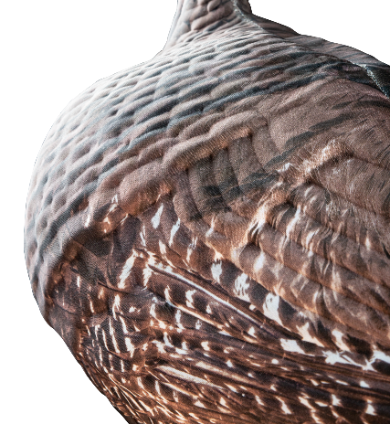
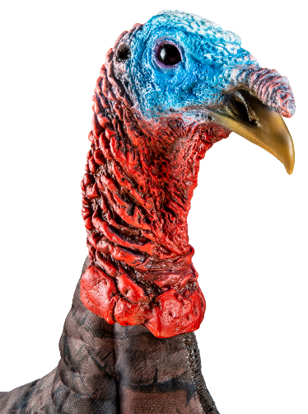
The most realistic decoy on the market! The Primos Photoform Jake Decoy looks like a young Jake looking to stake his claim. Utilizing a proprietary process that allows us to take actual imagery of a Jake and print it on 3D molded lightweight foam, this guy is just bold enough to get those birds fired up and ready to fight! Not only will this decoy be light enough to carry around all day, but it will also allow you to collapse it down to fit right in your vest.
- Proprietary Photoform process using actual imagery of a turkey
- Extremely lightweight and portable
- Realistic head coloration to trigger reaction from onlooking gobblers
- Content/Submissive body to drive gobblers insane

